1. Set slider to 3 seconds
2. Create a Sphere GameObject slightly in front of the Player Ships current coordinates. Scale it up to 20x20x20
3. Drag the **Sphere** from the Hierarchy down to the Timeline Animation Track and Select **Add** **Animation Track**.
4. Click Record and Jiggle the Sphere
   * Alternatively you could have right click the position for the Sphere and clicked **update key**
5. Move slider to 1 second and move ship a bit off the path
6. Move slider to 0 seconds and move ship off screen. Maybe even off the map.
7. Move slider to 5 seconds and move ship further along its path AFTER the interaction
8. Stop Recording and click Play to see the two movements. Make sure to click Game screen and click play to see it better.
9. If you want to edit the movement Right Click the Sphere timeline and select **Edit in Animation Window**

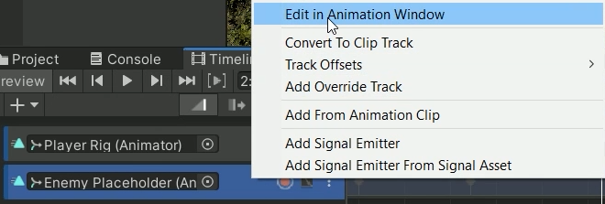

1. If you want to change the speed of your enemy you can select all points and use the blue bars to shorten/increase the time it takes to reach these points.
2. You can even move the time the sphere is at a certain position by dragging the top marker left/right
3. If you want to change the rotation/position of the enemy go to the timeline tab and select the Graph icon



1. expand the Position property

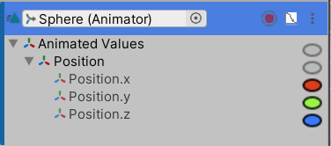

1. For instance at this moment I want my enemy to dip

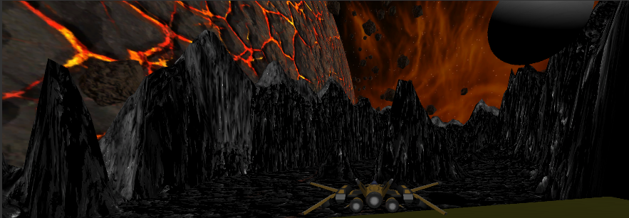

1. In my timeline I can decrease the y graph (green) at this specific moment in time to make it dip down. Rotation would have been an option if I had changed its rotation.
2. If I ever want to add another moment I can move the slider to that moment, right click and select Add Key. Then I can change the position/rotation at that moment.
3. There’s also handles on either side of a key frame so you can change the curve of the graph

